Topic 6 Addressing Co-Morbidities in Atopic Dermatitis Patients: Asthma, Sinusitis, and Other Complications
Part 1: Asthma
Scientific Panel Lecturer: Dr. R. Olivenstein
Community panelist: Rachel N. Asiniwasis, MD MS(HS) FRCPC FAAD

Comments Regarding Key points for: Dermatology Trainees
- No participant comments.

Comments Regarding Key points for: General Practitioners
- Dr. Jack commented that what was very interesting to her is how these populations overlap in prevalence but when severity is considered usually one epithelium dominates.
- Dr. Asai suggested that EoE should be mentioned by name, eosinophilic esophagitis, noting that it is often missed. Dr. Joseph agreed, saying that EoE is often missed and has picked up 2 or 3 in the past 2 years whereas previously had not seen any.
- Dr. Asai remarked that this was especially for primary care physicians because early intervention is key to avoidance of stricture and repeated dilations.
- Dr. jack agreed, saying that they need a GI recording and one for type I vs type IV HSS by A&I

Comments Regarding Key points for: Adults and Adolescents
- No participant comments.

Comments Regarding What Added Information is Needed
- No participant comments.

Comments Regarding Three Points Most Relevant to my Practice/Points Relevant to my Practice Not Found and/or Irrelevant info

- Dr. Besner Morin commented that she realizes that she does not question patients enough about symptoms of asthma, but always asks about joint pain in psoriasis patients. Dr. Purdy agreed. Saying that she asks “do you have asthma or seasonal allergies” but leaves it at that and now thinks that this is not sufficient.
- Dr. Besner Morin agreed, characterizing it as something to help her find the diagnosis of AD but not about severity or symptoms and if they have the appropriate follow up or treatment.
- Dr. Asai stated that she does an MDC with allergy and the asthma educator. She added that in Ontario they could qualify for dupilumab if they have 2 episodes requiring prednisone.
- Dr. Bourcier commented that he liked the table.
- Dr. Purdy commented that she would like a “ask these three things” list to make sure she did not miss asthma etc. Dr. Besner-Morin agreed and added that if the clinician knows the basics of the recommendation, your patient might not have EASI score to get dupilumab, but they might reach the threshold with asthma.

Key Takeaway: Vote Via Annotation
- Annotation exercise skipped for this presentation.

Overall Comments
- Dr. Prajapati asked Asiniwasis her opinion of the presentation. She responded that while it was very well done, she thought that some of the nuances on which treatments to choose based on experience rather than literature were perhaps too much for dermatologists/GPs, noting that she had to look up certain things, like GINA. She thought that what was missing was a slide on “Co-managing with dermatology” saying that they need to look at it in the same way that they co-manage psoriasis/psoriatic arthritis with rheumatologists.
- Dr. Prajapati commented that he would like some screening questions that dermatologists could use to screen for comorbidities.
- Dr. Lynde agreed, saying he would like 3 important questions that he could ask patients to screen for asthma, EoE and nasal polyps.
- Dr. Jack commented that there was a lot of disagreement on what dermatologists should be screening for and suggested that screening for mental health issues might be the most important. She commented that it seems to be if the AD is severe, the asthma is not as severe.
- Dr. Asiniwasis responded that the entire lecture was built around severe asthma and this might be a point to discuss.
- Dr. Purdy commented that more and more patients do not have access to primary care so she finds that if she screens for things that are relevant she may be able to direct them to another physician if needed.
- Dr. Besner-Morin commented that it’s important to know which novel treatments helps with other atopic disease because it might influence the choice of treatment. Dr. Purdy agreed. Dr. Besner-Morin added that they do not need to ask the questions all in the same visit as they are

being followed long term. Dr. Purdy agreed, saying that she would ask at baseline and should the clinical situation changes.
- Dr. Asiniwasis remarked that this is where the role of the GP can also really be considered but agreed with Dr. Purdy that many patients do not have a primary care physician and so she tries to screen patients and direct them to other physicians as needed.
- Dr. Asai asked if they prescribe inhalers or refer patients onwards. Dr. Purdy responded that she usually refers onwards and Dr. Asiniwasis replied that she will prescribe refills for inhalers if
they have a diagnosis of asthma in their chart, need it and can’t get into their GP, and ask them to follow up or refer if she deems it necessary. Dr. Purdy agreed, saying that she will refill but not initiate treatment as she may not be up to date.

Topic 6 Addressing Co-Morbidities in Atopic Dermatitis Patients: Asthma, Sinusitis, and Other Complications
Part 2: Chronic Rhinosinusitis with Nasal Polyposi
Scientific Panel Lecturer: Dr Tewfik Community panelist : David Adam MD FRCPC

Comments Regarding Key points for: Dermatology Trainees
- Regarding Point 3c, approved biologics, Dr. Adam, commented that this was relevant because there was the potential for treating more than one condition with the same medication.
- Dr. Besner-Morin commented that it would be interesting to know how many of their patients with AD had allergic rhinitis that needed treatment. Dr. Jack replied that the overlap with allergic rhinitis was the highest coexisting comorbidity.
- Dr. Asiniwasis agreed, saying that she sees a lot of allergic rhinitis in adults,.
- Dr. Asai commented that allergic rhinitis also has a massive impact on quality of life.

Comments Regarding Key points for: General Practitioners
- Dr. Adam noted that Point 3, Treatment of CRSwNP, was one point of differentiation between the GP and dermatology key points as the GPs need more information in order to be able to prescribe and give instructions to patients, noting that it was GPs who manage the treatment.
- Dr. Jack agreed with the need for specific names and instructions for corticosteroids, saying that this applies in AD as well.

Comments Regarding Key points for: Adults and Adolescents
- Dr. Adam commented on the need to normalize and validate the disease for the patient as well as have them understand that it is a chronic disease.
- Dr. Purdy commented that uses a light switch analogy to explain to patients the concept of psoriasis as a chronic disease that will wax and wane. She expanded on this saying, “I say the light has been switched on. We can’t turn it off but we can dim the lights.”

Comments Regarding What Added Information is Needed
- Dr. Adam remarked that he did not think that rhinitis is a concern/problem for patients that was sufficiently emphasized, noting its great impact on quality of life.
- Dr. Purdy agreed, referring to a Claritin advertising campaign that described how the patient felt and the impact of allergic rhinitis.

Comments Regarding Three Points Most Relevant to my Practice/Points Relevant to my Practice Not Found and/or Irrelevant info
- Dr. Asai commented that from speaking with respirology/allergy colleagues she has found that for asthma they often don’t use the medication dermatologists use because they have established and effective alternative biologics that are easier for them to get. She remarked that because of this, they might have to educate their colleagues to look for and prescribe the medications dermatologists use in AD rather than the other way around. She was not sure if this was similar with ENTs. Dr. Jack responded that ENTs use dupilumab but also overlap therapies with asthma. Dr. Prajapati commented that they really like using mepolizumab. Dr. Purdy commented that in her area ENTs favour benralizumab.
- Dr. Asiniwasis suggested emphasizing role of GP whenever possible.

Key Takeaway: Vote Via Annotation

Slide | Results
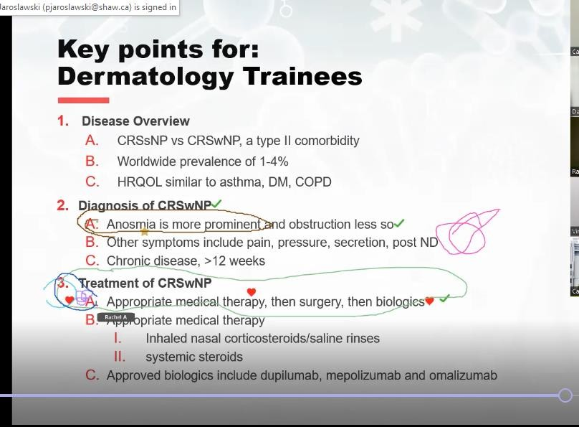 | 6. +Treatment of CRSwNP…-7 votes  7. +Diagnosis of CRSwNP…-3 votes

Overall Comments
- Dr. Lynde suggested having the comorbidities in one lecture with less detail.
- Dr. Besner-Morin commented that what was relevant to GPs was different from what was relevant to dermatology trainees. For dermatologists what is important to know is how severe, how common, what to ask and when to refer. For GPs it is great to have a resource online where they can learn not only about AD, but also about the comorbidities. They need to know what/how to write the prescription (exactly) for all the comorbidities at an entry-level. This type of resource is very valuable.

